**NANO (ETOYNM NANOS) POWERED PRECISION:**

**A ROBOTIC ARM WITH POTENTIOMATER CONTROL**

**BY**

**CUARESMA, MC KENNY**

**DOMINGO, JOHN ASHLEY**

**FELIPE, KAYE CEE**

**TALATTAD, KZANDREI CAMILO**

**TUMANENG, EXEQUIEL**

**ENGR. JEROME PAUL G. VIADOR**

**INSTRUCTOR**

1. **INTRODUCTION**

In today's world, robotics has become popular, useful and has achieved great success in many fields of humanity. Robotics has become very useful in medicine, education, military, science and mostly manufacturing world. It is a term that has since been used to refer to a machine that works to help people or to do jobs that people find difficult or undesirable. Robots, which can be on-destructive or non-destructive, perform tasks that would be very labor-intensive for humans. They can perform repetitive tasks faster and cheaper, and more accurately than humans. When properly applied, these disciplines led to the design of a very successful robot.

A robotic arm (also called a robotic manipulator) is mainly used in the manufacturing industry for repetitive material handling and precision tasks such as spot welding, assembly, cutting, palletizing, spray painting, etc. It is a programmable device with similar characteristics to the human hand and is best suited for hazardous environments where human intervention is highly undesirable [1]. Most robotic technologies that have been developed for other applications are those centered on robotic weapons. Robotic arms are mechanically controlled devices designed to reproduce the movement of a human arm. Lifting heavy objects and performing tasks that require extreme concentration and precision are the applications of these tools. The structure of a robot arm can vary depending on what it is intended for. The robot's arm consists of the following elements: controller, robot arm, and head effector, drives, and sensors; which are combined to form a whole, which all contribute to its proper functioning [2]; Controllers are the brains of the robot arms and serve as their primary processors. They can operate automatically programmed or allow manual operation by providing instructions directly from the user. The robot arm is the main part of the robot arm and consists of three parts: the shoulder, the elbow, and the wrist. These are all joints where the shoulder rests on the base of the arm, which is usually connected to a controller and can move forward, backward or rotate. An effector acts as the arm of the robot's arm. This part is in direct contact with the material handled by the robot. Some performance options include a gripper, vacuum pump, magnets, and welding torches. Actuators are mechanical devices that control the movement of the robot arm [3].

Servo motors are used to move arms. Servo motors are usually used as high-performance alternative to the stepper motor. Stepper motors have some inherent ability to control position and can often be used for open-loop position control without feedback to the \encoder, since their drive signal determines the number of rotational steps of motion. However, the lack of feedback limits their performance because a stepper motor can only move a load that is within its capacity. Otherwise, skipped Steps under load can cause positional errors [4]. The robotic arm's tasks in space included inspecting the space shuttle using a specially mounted boom where cameras and sensors were attached to the terminal, as well as deploying and retrieving satellites from the space shuttle's cargo hold [5].

Despite advancements in robotic technology, the focus remains on fine-tuning and agility. This research paper presents the design and development of a nano-electric precision robotic arm controlled by an intuitive potentiometer-based user interface. The Arduino Nano, a small and versatile microcontroller, is being used in this project due to its versatility and use in both educational and scientific settings.

This study discusses the complexities of the project, including design aspects, the construction process, and the deep working principles of the robotic arm. By studying these aspects, the work aims to contribute to the continuous development of user-centered and adaptive robot manipulators. In addition, the use of the Arduino Nano platform promotes accessibility and affordability, making this project a valuable tool for students, hobbyists, and researchers. The research paper examines in more detail, the selection and justification of the Arduino Nano microcontroller and its suitability for the project, design options for the structure of the robot arm, considering factors such as material selection, weight distribution and trajectory, integration of potentiometers into the control system, including their placement and signal processing techniques used, development of Arduino Nano control software that converts potentiometers into corresponding hand movements, evaluation of the performance of robotic arms, focusing on factors such as accuracy, repeatability, and overall efficiency.

Addressing these aspects, the study aims not only to document the creation of this robotic arm, but also to provide valuable information for future efforts to develop user-friendly and versatile robotic systems.

**OBJECTIVE OF THE STUDY**

Design and build a robotic arm that can be controlled using multiple potentiometers and an Arduino Nano microcontroller. The robotic arm should be able to move its joints based on the user’s input on the potentiometers. Specifically aims to:

1. To control the robot arm in spatial movement.
2. To show the current angle position on the potentiometer using 8x8 LED matrix display.
3. To test, calibrate, and show the voltage per degree of the potentiometer.
4. Create an activity for the robotic arm to follow a shape drawn on a flat surface. This requires precise movements and following a specific shape.

**CONCEPTUAL FRAMEWORK**

|  |  |  |  |  |
| --- | --- | --- | --- | --- |
| **INPUT** |  | **PROCESS** |  | **OUTPUT** |
|  |  |  |  |  |
| * Potentiometer Readings (voltage signals) representing desired joint positions.      * Button control for the grip of the arm. * Magnetic encoder for the 360-degree movement of the base |  | * Arduino Nano reads analog voltage from potentiometers. * Converts voltage readings to desired joint angles. * Sends Pulse Width Modulation (PWM) signals to servo motors based on calculated angles. * Converts the voltage readings to move the grip (open and close) * Robotic arms identify specific shapes. Sensors guide, angles move, gripper grabs, PWM sorts. * Detects rotational position information as changes of the magnetic field, converts them into electrical signals, and out them. |  | * Movement of the robotic arm joints to corresponding positions. * Show the level of adjustment of the potentiometer with the use of 8x8 LED matrix display. |

Sensors act as the arm's eyes, feeding real-time position data to a microcontroller, the brain of the system. The microcontroller interprets this data and user input, calculating precise motor commands. These commands translate to smooth, controlled movements and gripping actions by the robotic arm.

1. **METHODOLOGY**

**OVERVIEW OF THE STUDY**

This digital landscape brings to life a precisely designed 3D model of a robotic arm. All components, from the sturdy base to the end effector (adaptive grip), are crafted with intricate details. This virtual representation allows a close-up view of its mechanics, revealing the complexity of its movement and its potential for various tasks.

**Figure 2.1 Base of the Arm**

The base of a robotic arm is typically the part that attaches the arm to a floor or other stable surface. It provides stability for the arm and ensures that it can move the arm precisely. The base may also house some of the motors or gears that drive the arm's movements.

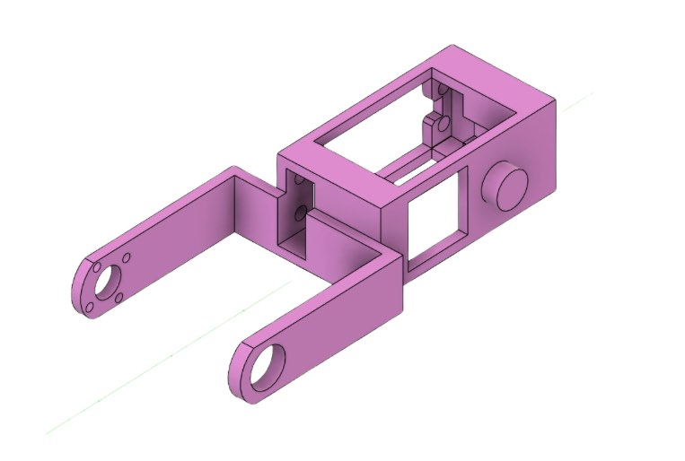

**Figure 2.2 Upper and Lower Arm Model**

The upper and lower arm models combine to form the robotic arm's reach. Multiple joints, like a human shoulder and elbow, allow for extension, retraction, and precise articulation. This flexibility lets the arm precisely position its end effector for various tasks.

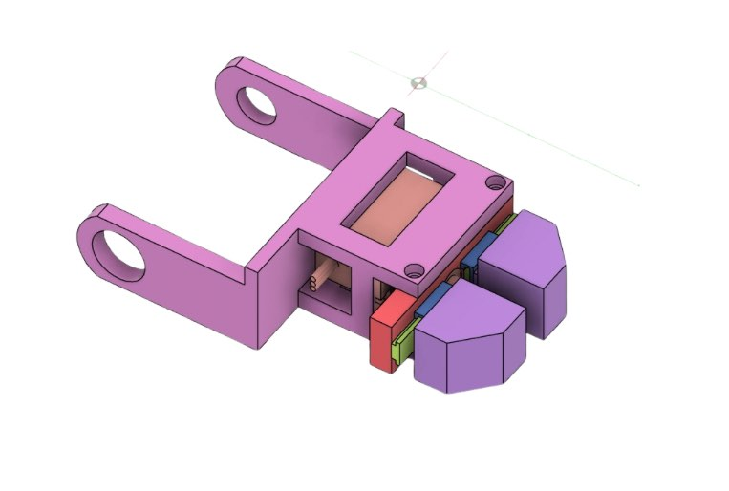

**Figure 2.3 End Effector**

The gripper serves as the arm's "hand," enabling it to grasp and interact with the environment. Precise control over the gripper, possibly through potentiometers in the robotic arm, is critical for achieving the precision and versatility required for various tasks.

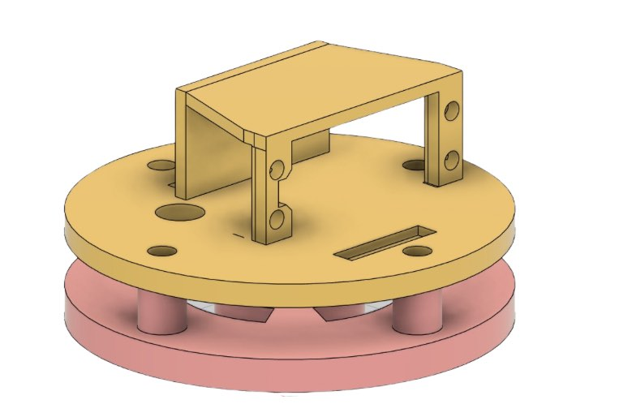

**Figure 2.4 Shoulder Mesh**

This robotic shoulder mesh offers human-like range of motion, enabling flexible arm movement and precise positioning. Providing 180 degrees rotation.

Figure 2.5 The Whole Arm

This is the whole Robotic arm when combining all the parts together. Enables the functions as a whole. Providing the functions of a arm.

The study follows a spiral, starting with a core idea, identifying potential issues, building a basic model, and rigorously testing it to improve and refine the design.

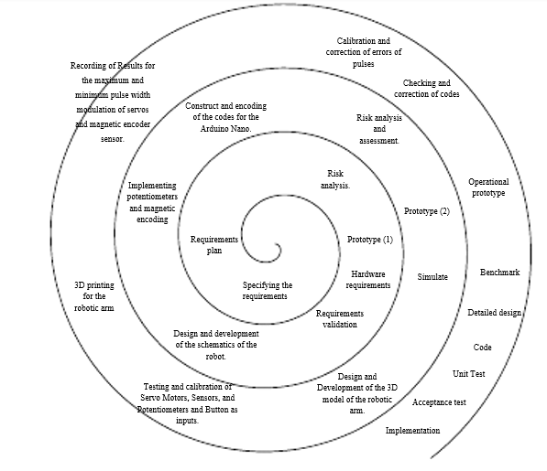

**Figure 2.5 Research Model**

The study employs a spiral design, which is an iterative process that prioritizes risk reduction and ongoing research improvement. By using a cyclical structure,problems can beidentified and minimized in advance so that research advances through regular reviews and feedback in manageable stages. With the spiral model, research aims to achieve a high level and adaptability, leading to stronger and more reliable results

Here's a breakdown of the four stages:

**Define Objectives, Alternatives, and Constraints:** This involves identifying the purpose of the robotic arm (e.g., assembly, pick-and-place), considering different arm designs (e.g., articulated, SCARA), and acknowledging limitations like weight or reach.

**Evaluate Alternatives, Identify and Resolve Risks:** Different designs are assessed for factors like precision, speed, and cost. Potential risks like motor overheating or instability are identified, and solutions are devised (e.g., cooling systems, sturdier materials).x9

**Develop and Verify Next Level Product:** A prototype arm is built based on the chosen design. Simulations or initial hardware testing are conducted to ensure it meets the desired performance.

**Plan the Next Iteration:** The prototype's performance is evaluated. The team might refine the design, address shortcomings, or proceed with further development based on the findings. This iterative process continues until the final robotic arm meets all requirements.

The potentiometer is calibrated by determining the minimum and maximum pulse width modulation (PWM) to determine the 0- and 180-degree angle. In addition, we use the map function to use the PWM to calibrate the potentiometer on its equivalent degree level.

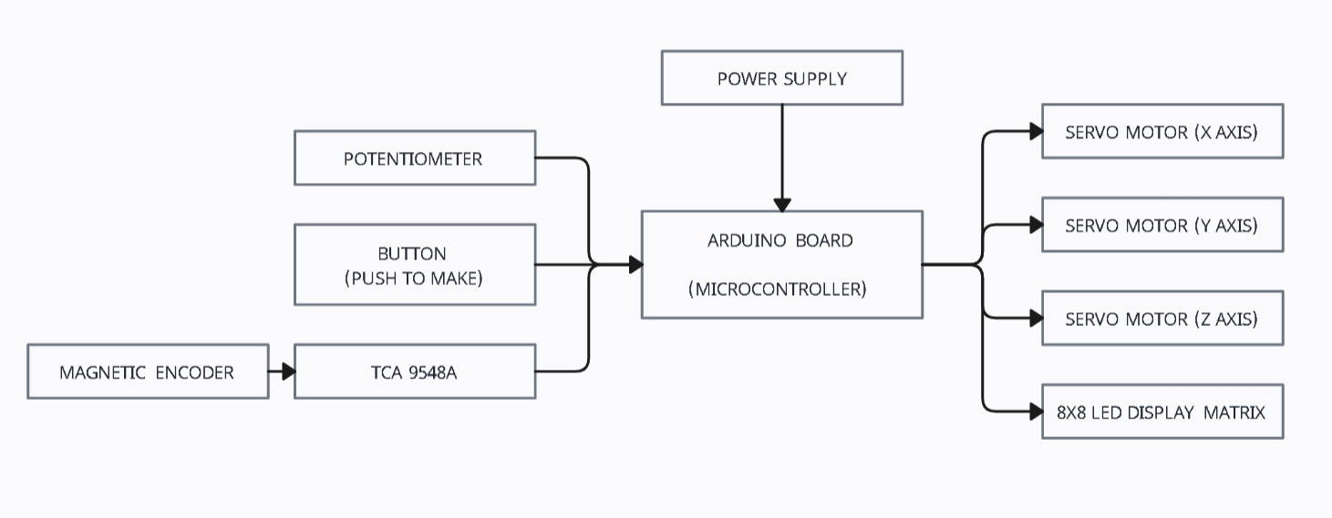

**Figure 2.6 Block Diagram**

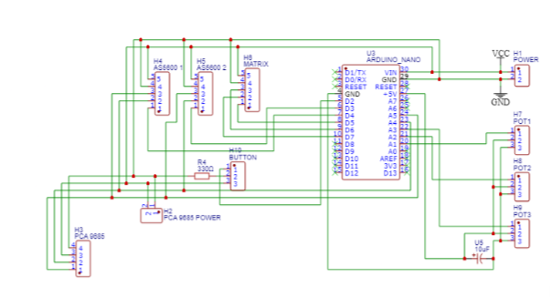

**Figure 2.7 Schematic Diagram with pin configuration**

**APPENDICES**

|  |  |  |
| --- | --- | --- |
| **Materials** | **Usage** | **Specifications** |
| MG995 High Torgue Metal Gear Analog Servo for RC Airplane Models  Replacement Part Accessory | Lazada PH  MG995 Servo Motor | * Manipulating objects with torque range. * Suitable for robotic joints with 360-degree rotation. * Adequate speed for steering in mobile robots. * Useful in animatronics for realistic movements. | * RPM: 0.20s/60 degrees (4.8V), 0.16s/60 degrees (6V) * Voltage: 4.8V - 6.6V. * Torque: 9.4kg/cm (4.8V) - 11kg/cm (6V) * Angle: 360 degrees. * Weight: 55g. * Dimensions: 40 x 20 x 43 mm / 1.6" x 0.8" x 1.7" |
| SG92R Digital servo | RC Factory  SG92R | * Controlling small robotic arms or grippers. * Creating animatronic movements. * Operating small mechanisms. * Manipulating lightweight objects. * Educational projects using robotics or servo motors. | * Stall torque: 2.5 kg/cm. * Operating speed: 0.1 s/60 degree. * Operating voltage: 4.8 V (~5V) * Temperature range: 0 ºC - 55 ºC. * Dead band width: 1us. * Servo wire length: 25 cm. * Servo Plug: JR (Fits JR and Futaba) * Dimensions: 22.2 x 11.8 x 31 mm approx. |
| MG996R Servo Motor Datasheet, Wiring Diagram & Features  MG996 Servo Motor | * Supports arm weight and carrying objects. * Requires most power among arm's joints. * Suitable for robotic joints with 180-degree rotation. | * Weight: 55 g * Dimensions: 40.7 x 19.7 x 42.9 mm * Stall torque: 9.4 kgf.cm (4.8 V), 11 kgf.cm (6 V) * Operating speed: 0.17 s/60° (4.8 V), 0.14 s/60° (6 V) * Operating voltage: 4.8 V–7.2 V * Running current: 500 mA–900 mA (6 V) * Stall current: 2.5 A (6 V) * Dead band width: 5 μs * Temperature range: 0–55°C |
| AS5600 Magnetic Angle Sensor Encoder Module - AS5600MOD  AS5600 | * Provides precise feedback on servo's position. * Mounted on output shaft for real-time data on arm's joint angles. * Allows closed-loop control for high accuracy. | * Non-contact magnetic induction angle measurement module. * High precision, a variety of output modes: IIC, PWM, and voltage. * Power Supply: 3.3V DC. * Approximate size: 0.906 x 0.906 in. * Weight - 24g |
| Potentiometer - Wikipedia  POTENTIOMETER | * Offers superior precision. * Allows adjustment of voltage. * Allows manual control of arm position. * Ideal for calibration or initial setup. | * 10K Ohm. * Dual turn. * 1 Watt. * Shaft Length: 15mm. * Shaft diameter: 6.35mm. * ±10% tolerance. * Life Cycle: 10,000 operations. |
| Push Button Switches | Railwayscenics  PUSH TO MAKE BUTTON | * User-friendly trigger for specific actions. * Programs pre-defined movements. * Initiates grasping sequences. * Serves as safety stop button. | * Mode of Operation: Tactile feedback * Power Rating: MAX 50mA 24V DC * Insulation Resistance: 100Mohm at 100v * Operating Force: 2.55±0.69 N * Contact Resistance: MAX 100mOhm * Operating Temperature Range: -20 to +70 ℃ * Storage Temperature Range: -20 to +70 ℃ |

**RESULTS AND DISCUSSION**

This study aimed to design a nano-electric precision robotic arm controlled by potentiometers and an Arduino Nano microcontroller. The arm achieved three-axis manipulation and demonstrated high proportionality between user input and movement. We evaluated the arm's movement accuracy and repeatability through extensive testing and calibration. The arm completed pre-programmed and follows the shape position of varying complexity, with a near-perfect success rate for simpler shape positional. In addition, the researchers also aimed to get the voltage by degree of the servo motor. To get the voltage per degree, the researchers acquired the max and minimum voltage of the potentiometer by measuring the voltage when the potentiometer is in its resting position and max position. To solve it, the researchers use the following formula: $Voltage_{Degree}={(V}_{max}-V_{min})/highest degree$

$$V_{max}=2.71V$$

$$V_{min}=2.53V$$

$$Voltage_{Degree}=\frac{2.71V-2.53V}{180}degree$$

$$Voltage_{Degree}=0.001V$$

|  |  |
| --- | --- |
| Degree | Values in Voltage |
| 0 | 2.53V |
| 10 | 2.54V |
| 20 | 2.55V |
| 30 | 2.56V |
| 40 | 2.57V |
| 50 | 2.58V |
| 60 | 2.59V |
| 70 | 2.60V |
| 80 | 2.61V |
| 90 | 2.62V |
| 100 | 2.63V |
| 110 | 2.64V |
| 120 | 2.65V |
| 130 | 2.66V |
| 140 | 2.67V |
| 150 | 2.68V |
| 160 | 2.69V |
| 170 | 2.70V |
| 180 | 2.71V |

This result suggests a linear relationship between the angle of rotation of the potentiometer and the voltage it outputs. In other words, for every degree you rotate the knob, the voltage increases by a consistent 0.001 V.

Further development of this project may concentrate on improving control precision, expanding the range of jobs the arm can execute, and adding more sensors for more sophisticated capabilities. All things considered, the project met its goals and laid a strong basis for further developments in user-centered and adaptable robotic systems.

**CONCLUSION**

The study's main goals of three-axis control and accurate movement were successfully developed by creating a nano-electric precision robotic arm that is managed by potentiometers and an Arduino Nano microcontroller. The system is especially useful for teaching because of its user-friendly interface and 8x8 LED matrix display, which provides real-time visual feedback. The arm's dependability and efficacy in illuminating basic robotics and control concepts are highlighted by its capacity to execute tasks with great precision and repeatability, particularly in less complex shape positioning.

**REFERENCES**

[1] A. Rama Krishna, G. Sowmya Bala, A.S.C.S. Sastry, B. Bhanu Prakash Sarma, Gokul Sai Alla “Design And Implementation Of A Robotic Arm Based On Haptic Technology” IJERA, Vol. 2, Issue 3, May-Jun 2012,

[2] Brahmani K., Roy K.S, Arm 7 Based Robotic Arm Control by Electronic Gesture Recognition 2013; 4: 1245–1248.2. Elfasakhany A, Design and Development of a Competitive Low-Cost Robot Arm with Four Degrees of Freedom. Modern Mechanical

Engineering 2011

[3] Jegede Olawale, Awodele Oludele, Ajayi Ayodele, “Development of a Microcontroller Based Robotic Arm”, in Proceedings of the 2007 Computer Science and IT Education Conference pg: 549-557

[4] Lens T, Von Stryk O, Design and dynamics model of a lightweight series elastic tendon-driven robot arm. Proceedings - IEEE International Conference on Robotics and Automation 2013; 4512–4518.

[5] Paul E. Sandin, “Robot Mechanisms and Mechanical Devices Illustrated” chapter 7, pp-203.

**DOCUMENTATION**

|  |  |  |  |
| --- | --- | --- | --- |
|  |  |  |  |
|  |  |  |  |
|  |  |  |  |